**Análisis de datos del aserradero**

***17 / 01 / 2025***

**Primer corte | 8 cortes la hora 9:34**

|  |  |  | A mano | Real |
| --- | --- | --- | --- | --- |
| Tronco | Inicio | Grosor(cm) | Tiempo(seg) | Tiempo(seg) |
| 1 | 9:34 | 28cm | 6,33 | 6 |
|  |  |  | 6,05 | 6 |
|  |  |  | 5,27 | 5 |
|  |  |  | 5,46 | 5 |
|  |  |  | 5,58 | 5 |
|  |  |  | 6,88 | 4 |
|  |  |  | 5,73 | 6 |
|  |  |  | 6,75 | 6 |



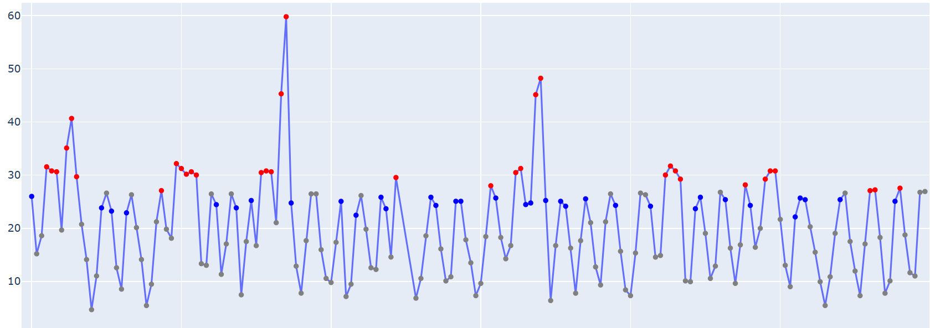

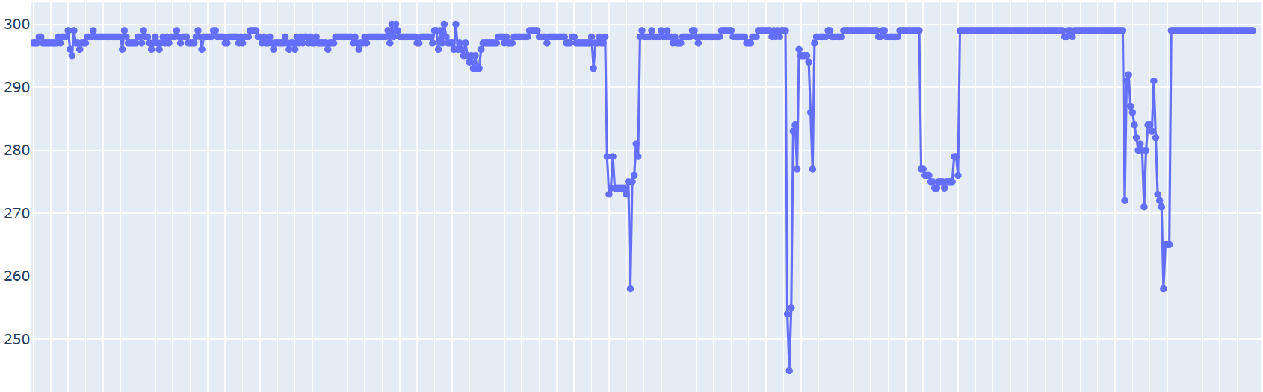

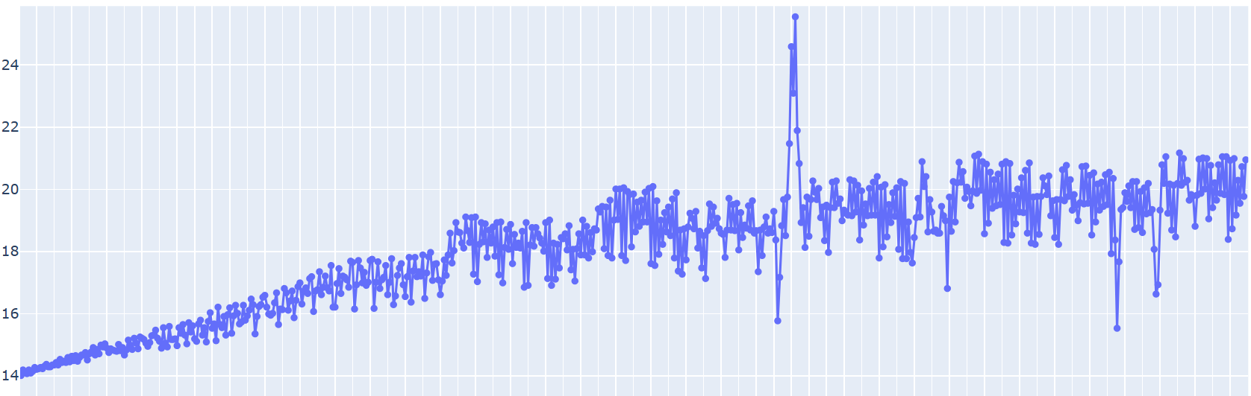

**Segundo corte | 6 cortes la hora 9:37**

|  |  |  | A mano | Real |
| --- | --- | --- | --- | --- |
| Tronco | Inicio | Grosor(cm) | Tiempo(seg) | Tiempo(seg) |
| 2 | 9:37 | 26cm | 5,53 | 7 |
|  |  |  | 5,20 | 6 |
|  |  |  | 5,27 | 7 |
|  |  |  | 5,53 | 6 |
|  |  |  | 5,75 | 11 |
|  |  |  | 5,52 | 7 |

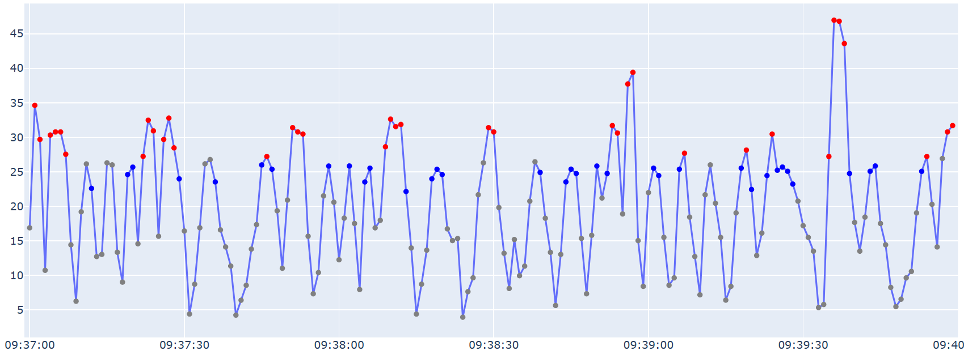

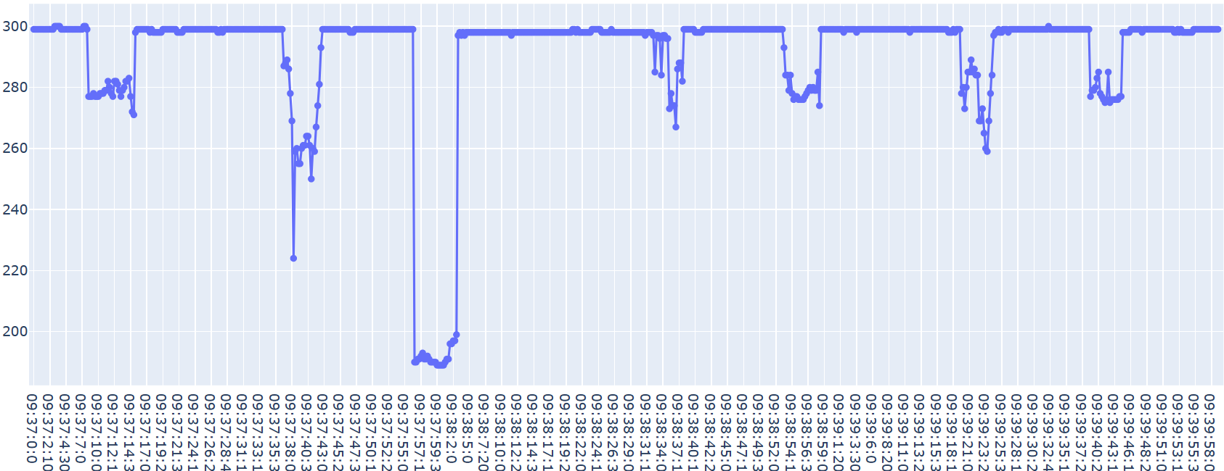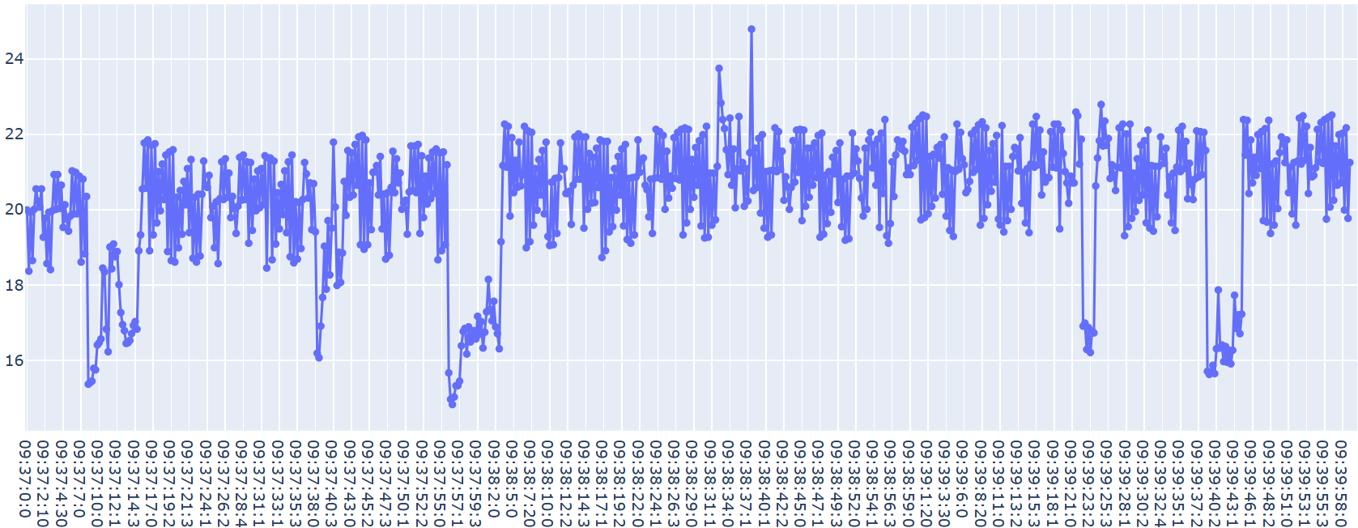

**Tercer corte | 7 corte la hora 9:40**

|  |  |  | A mano | Real |
| --- | --- | --- | --- | --- |
| Tronco | Inicio | Grosor(cm) | Tiempo(seg) | Tiempo(seg) |
| 3 | 9:40 | 26cm | 5,58 | 5.7 |
|  |  |  | 5,79 | 6 |
|  |  |  | 4,93 | 5 |
|  |  |  | 5,10 | 2.4 |
|  |  |  | 5,33 | 4.1 |
|  |  |  | 4,74 | 5.2 |
|  |  |  | 5,60 | 6 |

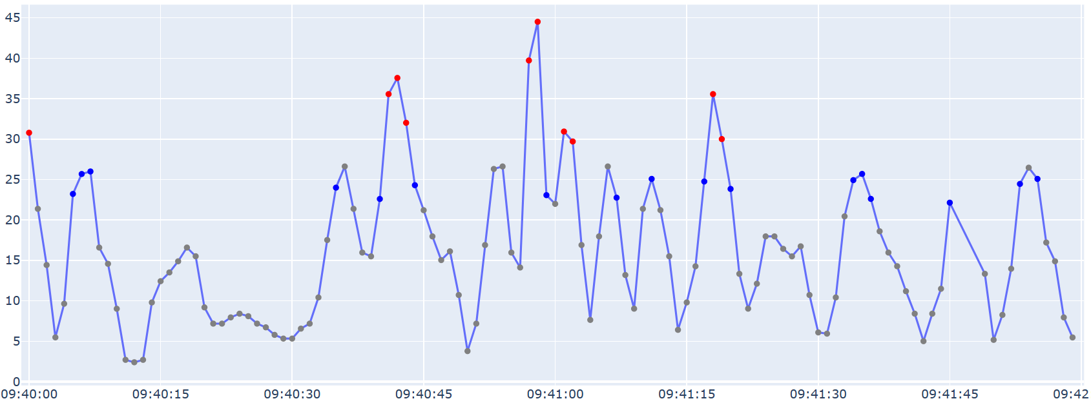

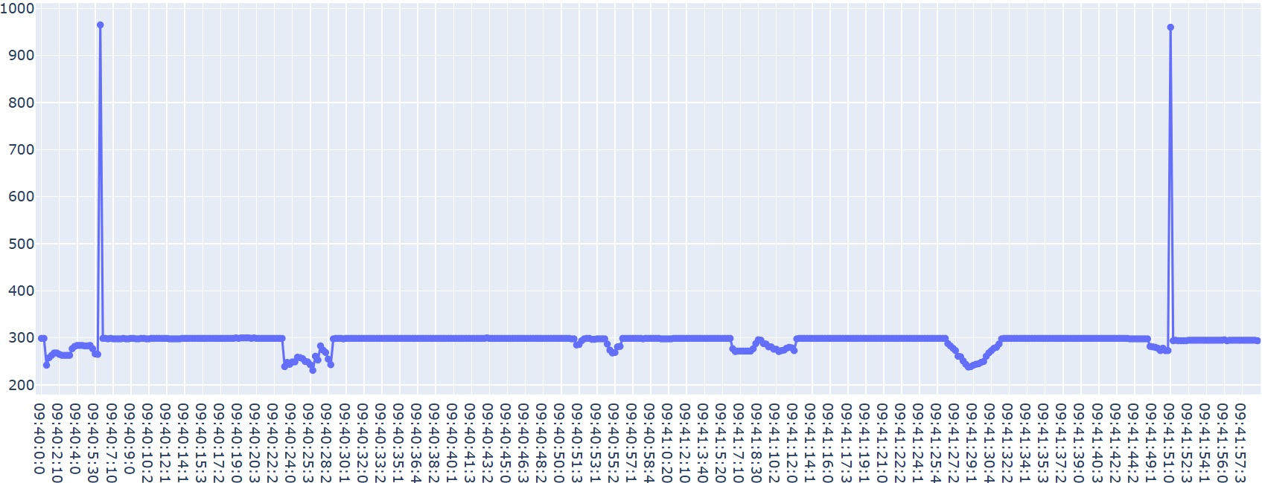

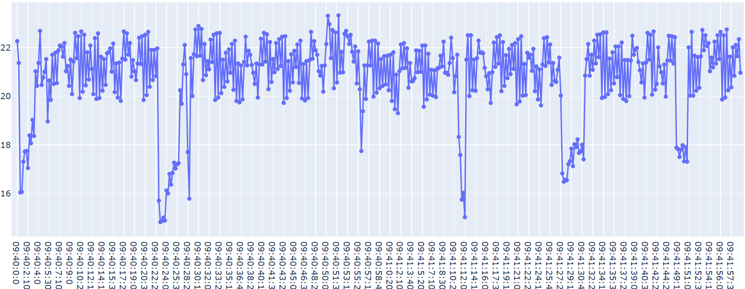

**Cuarto corte | 9 corte la hora 9:42**

|  |  |  | A mano | Real |
| --- | --- | --- | --- | --- |
| Tronco | Inicio | Grosor(cm) | Tiempo(seg) | Tiempo(seg) |
| 4 | 9:42 | 30cm | 4,68 | 5.9 |
|  |  |  | 5,59 | 5 |
|  |  |  | 5,31 | 6.1 |
|  |  |  | 4,96 | 5.5 |
|  |  |  | 5,14 | 5.1 |
|  |  |  | 4,73 | 5.2 |
|  |  |  | 4,59 | 4.9 |
|  |  |  | 5,20 | 5 |
|  |  |  | 7,44 | 51 |

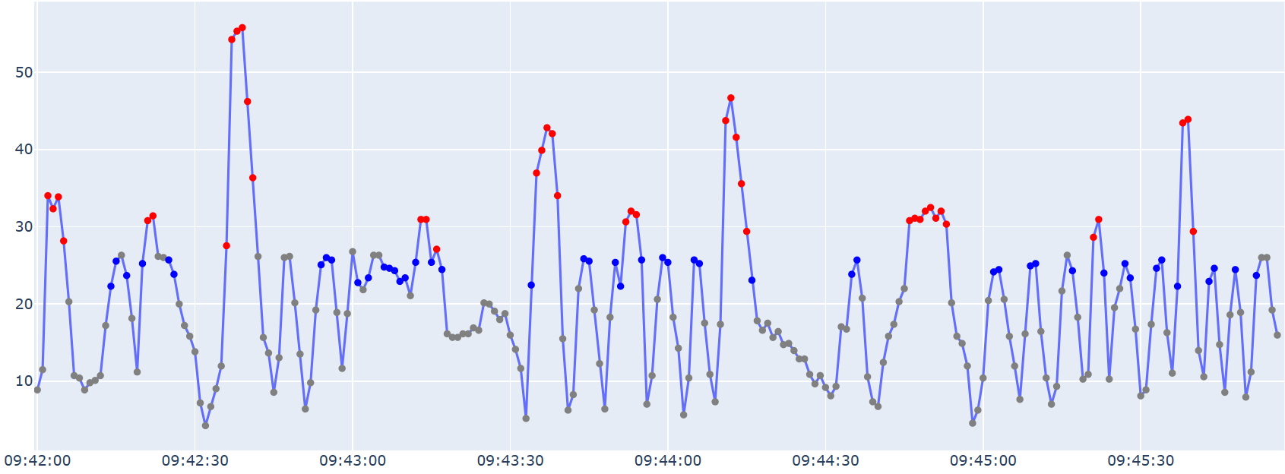

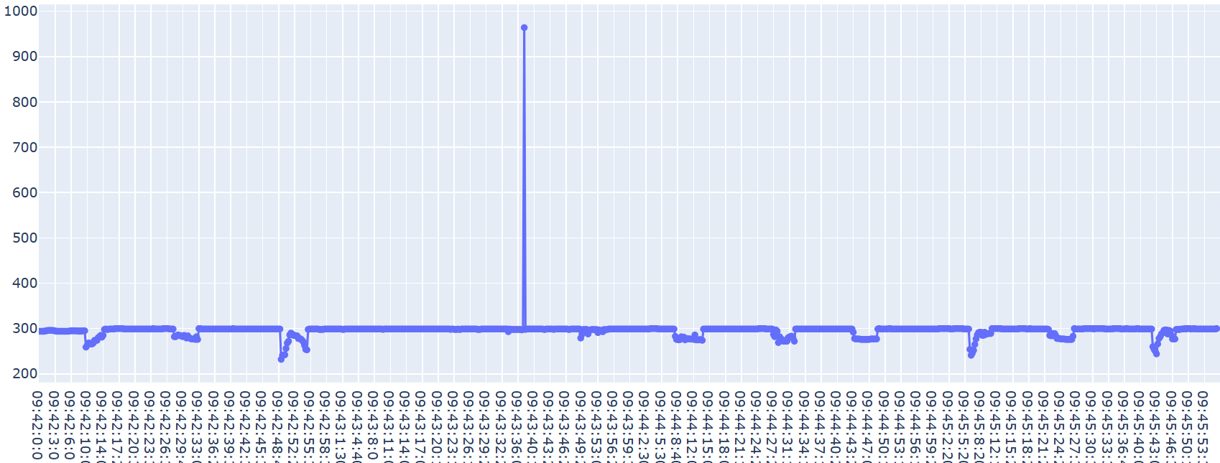

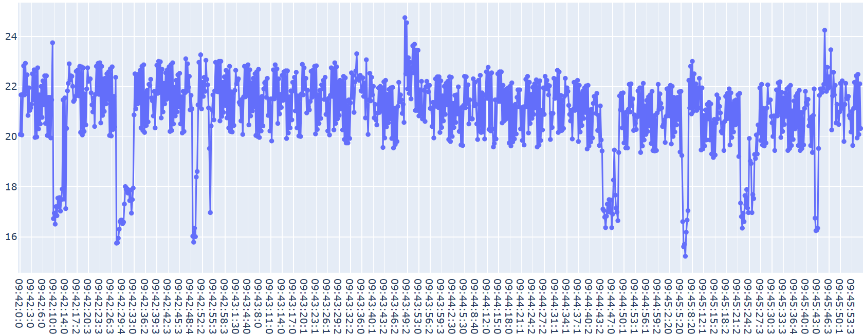

**Quinto corte | 7 corte la hora 9:46**

|  |  |  | A mano | Real |
| --- | --- | --- | --- | --- |
| Tronco | Inicio | Grosor(cm) | Tiempo(seg) | Tiempo(seg) |
| 5 | 9:46 | 24cm | 5,00 | 4.6 |
|  |  |  | 5,14 | 7.8 |
|  |  |  | 5,12 | 5.2 |
|  |  |  | 4,68 | 5.3 |
|  |  |  | 4,94 | 2.7 |
|  |  |  | 4,48 | 3 |
|  |  |  | 4,73 | 5.2 |

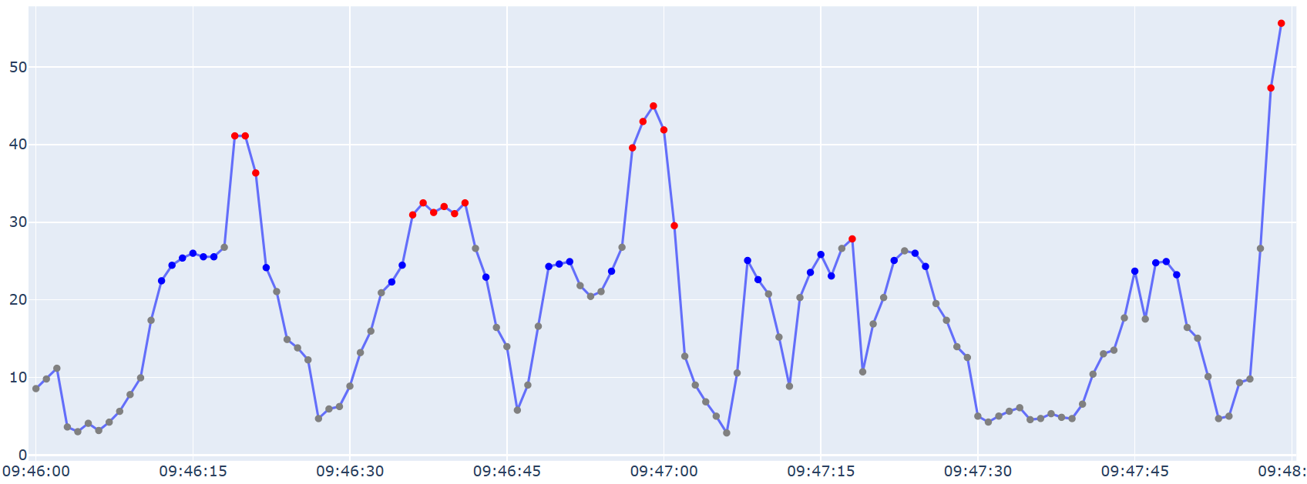

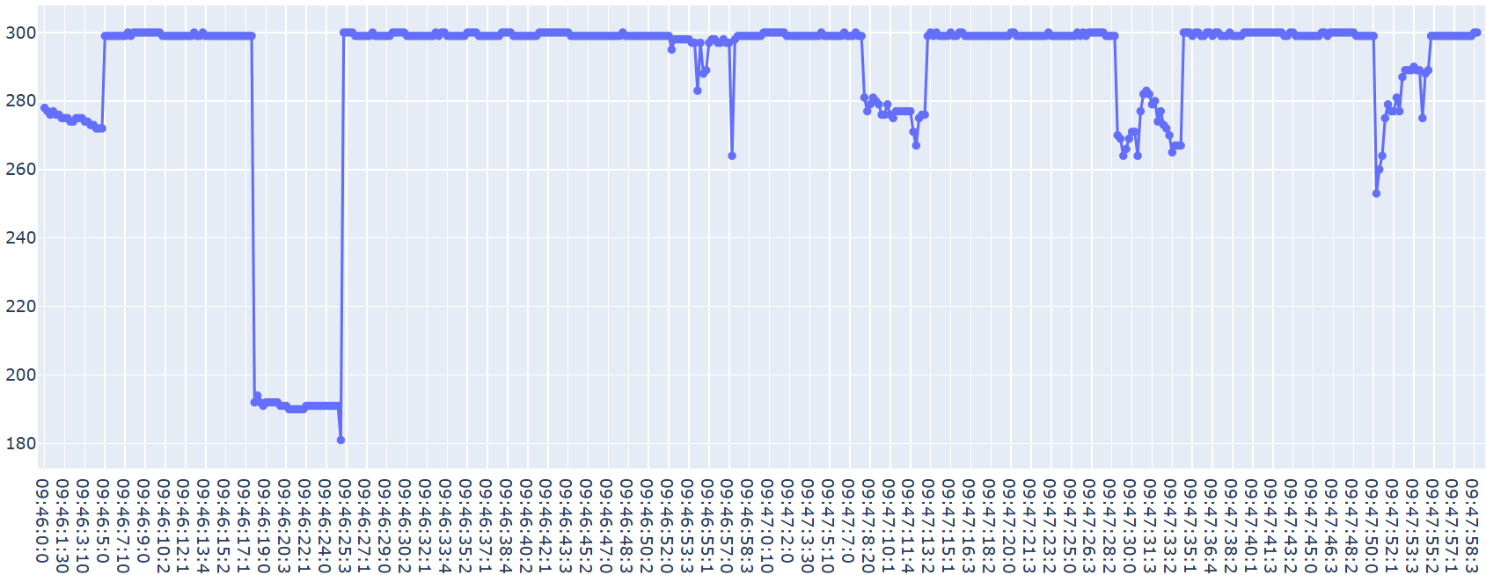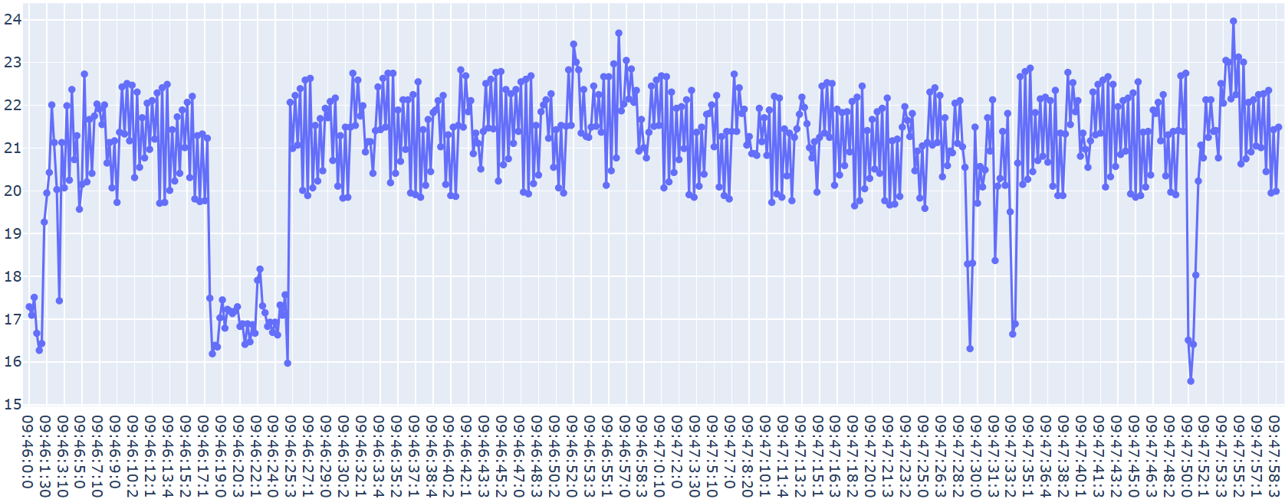

**Sexto corte | 9 corte la hora 9:48**

|  |  |  | A mano | Real |
| --- | --- | --- | --- | --- |
| Tronco | Inicio | Grosor(cm) | Tiempo(seg) | Tiempo(seg) |
| 6 | 9:48 | 28cm | 5,26 | 5,1 |
|  |  |  | 5,46 | 5,8 |
|  |  |  | 4,18 | 5,7 |
|  |  |  | 4,00 | 6,2 |
|  |  |  | 4,67 | 5,2 |
|  |  |  | 4,63 | 6,0 |
|  |  |  | 5,00 | 5,8 |
|  |  |  | 5,06 | 5,0 |
|  |  |  | 5,52 | 5,1 |



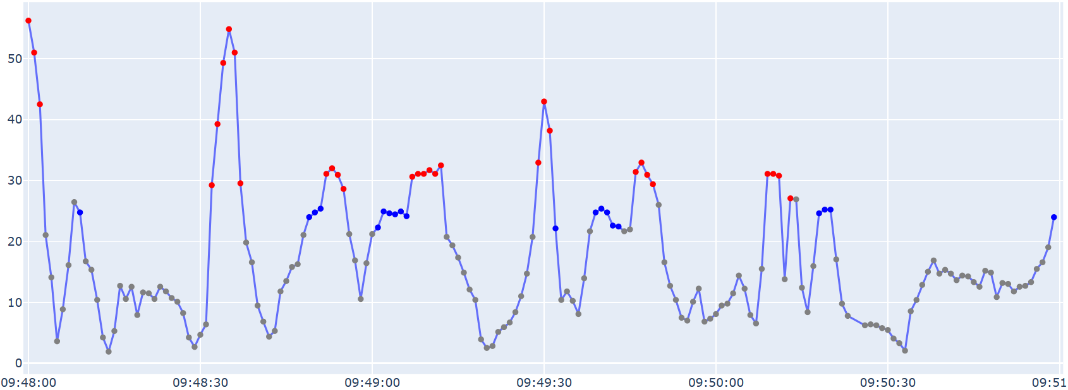

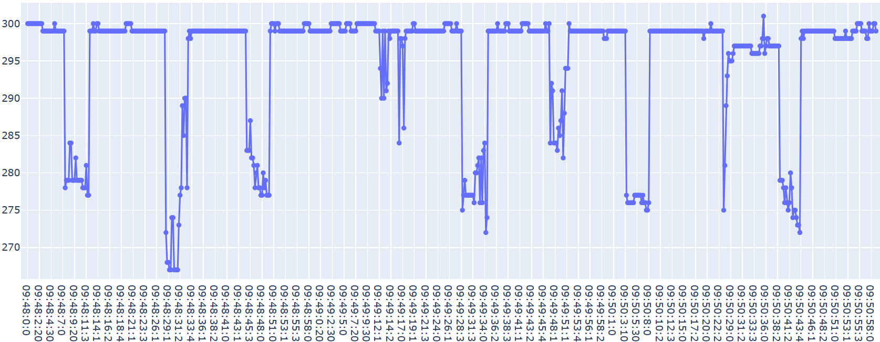

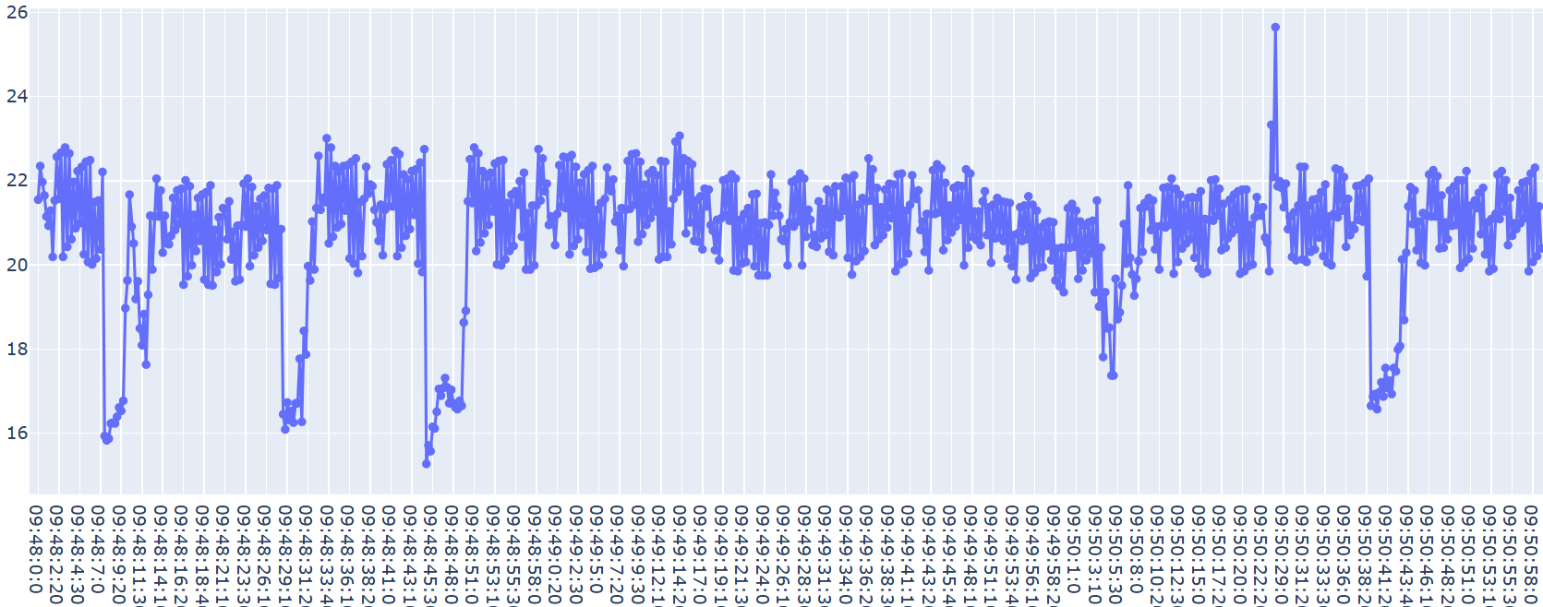

**Séptimo corte | 8 corte la hora 9:51**

|  |  |  | A mano | Real |
| --- | --- | --- | --- | --- |
| Tronco | Inicio | Grosor(cm) | Tiempo(seg) | Tiempo(seg) |
| 7 | 9:51 | 30cm | 5,2 | 5,9 |
|  |  |  | 5,52 | 4,8 |
|  |  |  | 6,04 | 6 |
|  |  |  | 5,32 | 6 |
|  |  |  | 5,66 | 6,2 |
|  |  |  | 5,20 | 6 |
|  |  |  | 4,75 | 6,1 |
|  |  |  | 5,06 | 5,2 |

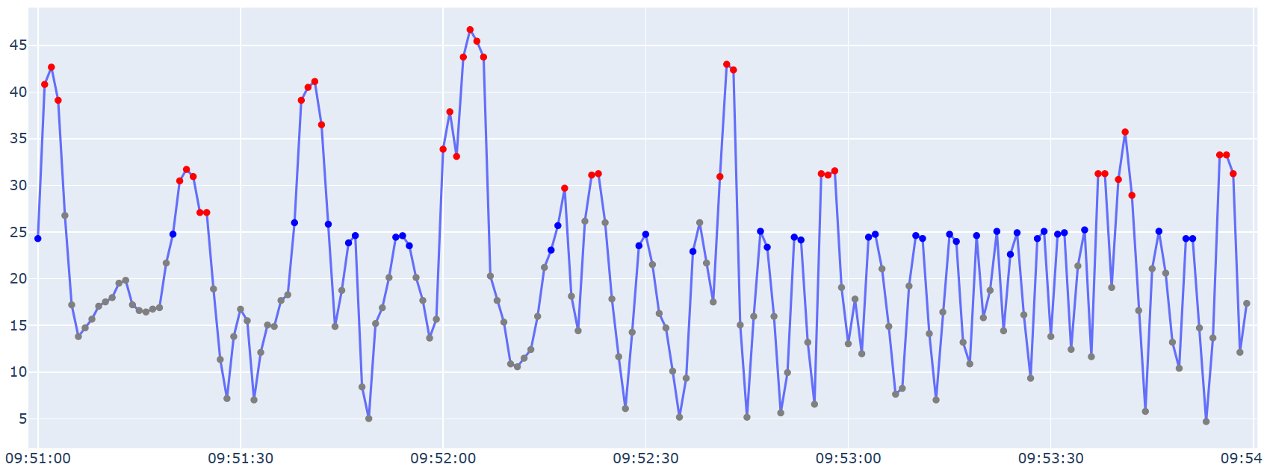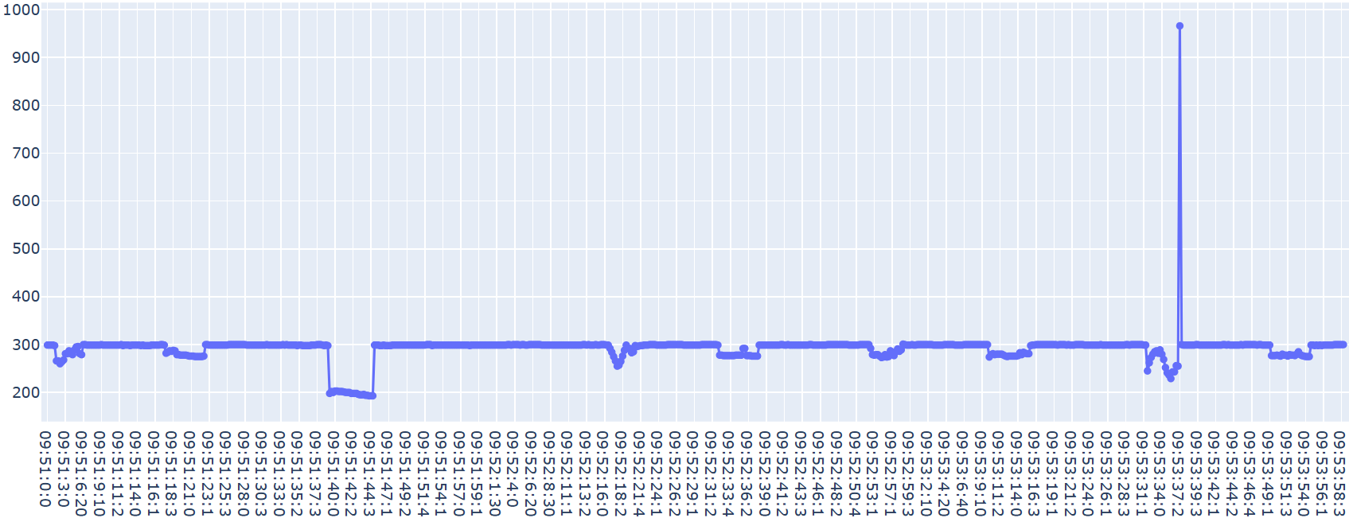

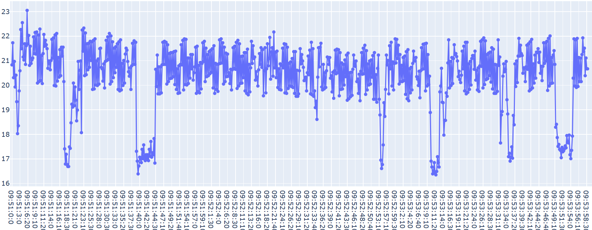

**Octavo corte | 12 corte la hora 9:54**

|  |  |  | A mano | Real |
| --- | --- | --- | --- | --- |
| Tronco | Inicio | Grosor(cm) | Tiempo(seg) | Tiempo(seg) |
| 8 | 9:54 | 38cm | 5,33 | 5,6 |
|  |  |  | 5,85 | 5,9 |
|  |  |  | 5,85 | 6 |
|  |  |  | 5,06 | 5,6 |
|  |  |  | 4,45 | 5,8 |
|  |  |  | 4,94 | 5 |
|  |  |  | 5,07 | 5,9 |
|  |  |  | 5,33 | 5,9 |
|  |  |  | 6,45 | 6 |
|  |  |  | 7,29 | 11 |
|  |  |  | 8,01 | 8,7 |
|  |  |  | 6,24 | 6 |

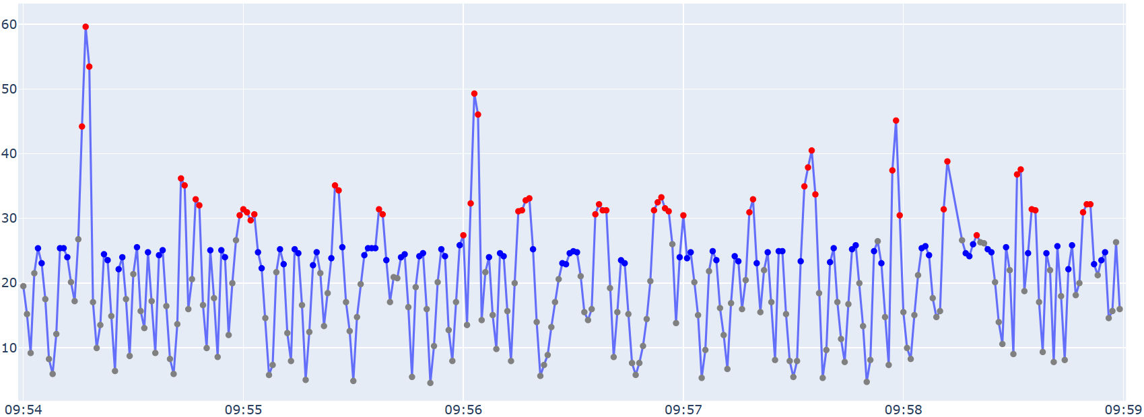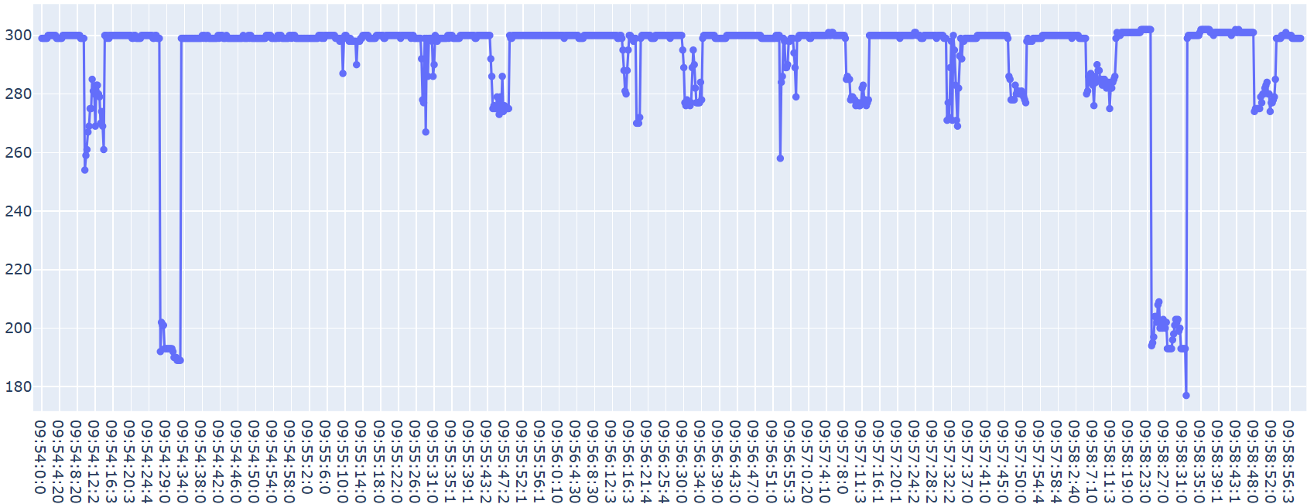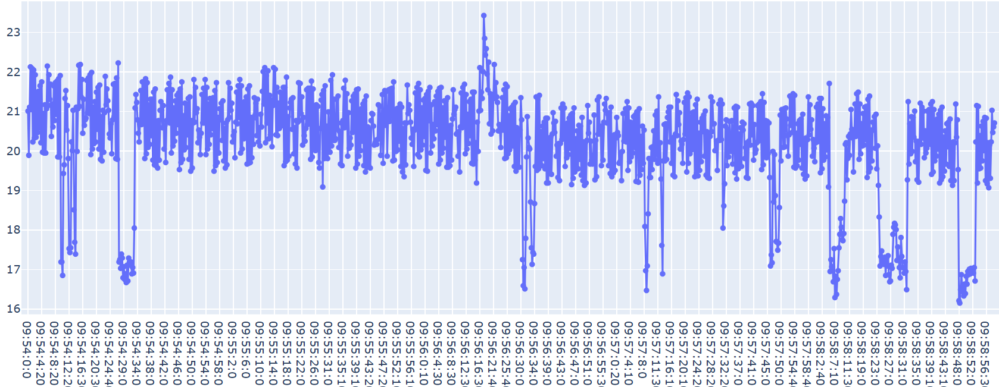

**Noveno corte | 5 corte la hora 9:59**

|  |  |  | A mano | Real |
| --- | --- | --- | --- | --- |
| Tronco | Inicio | Grosor(cm) | Tiempo(seg) | Tiempo(seg) |
| 9 | 9:59 | 30cm | - |  |
|  |  |  | - |  |
|  |  |  | - |  |
|  |  |  | 4,88 | 6,1 |
|  |  |  | 5,39 | 7 |
|  |  |  | 4,65 | 5,9 |
|  |  |  | 4,80 | 6,6 |
|  |  |  | 5,86 | 4,9 |

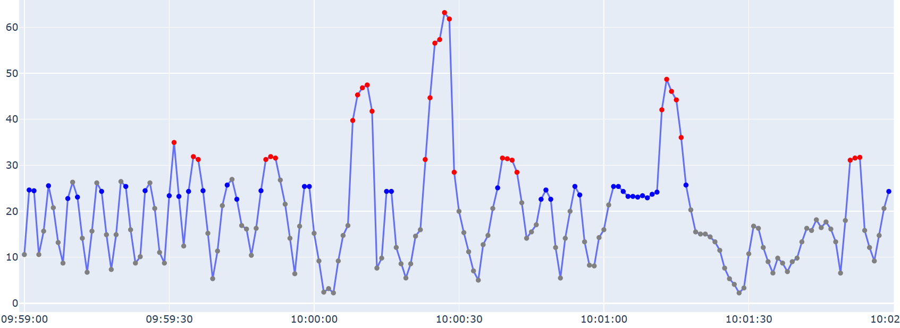

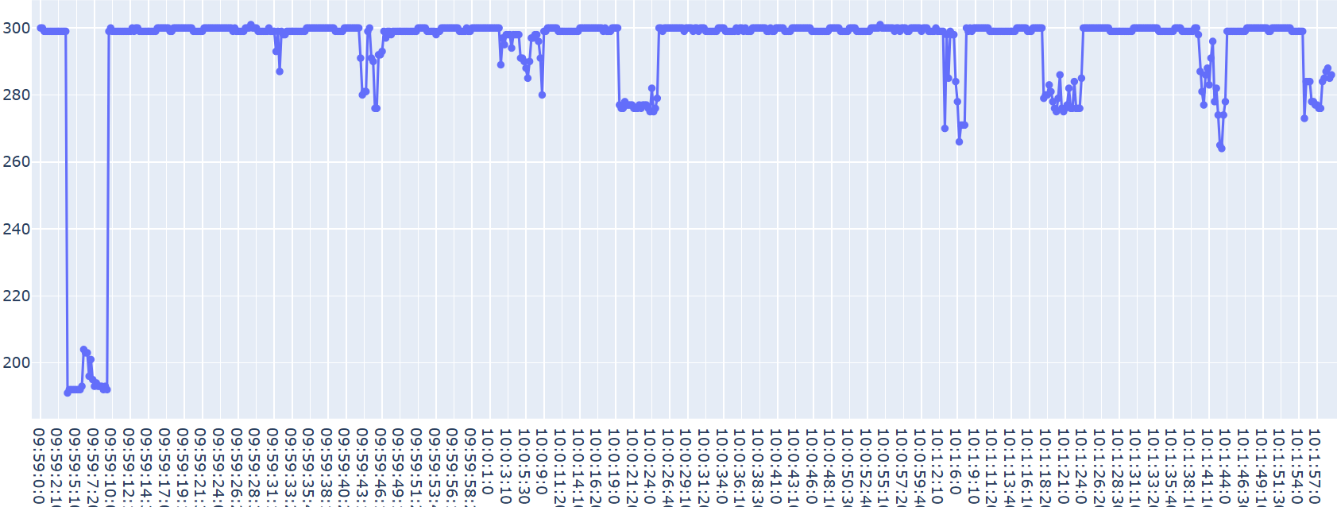

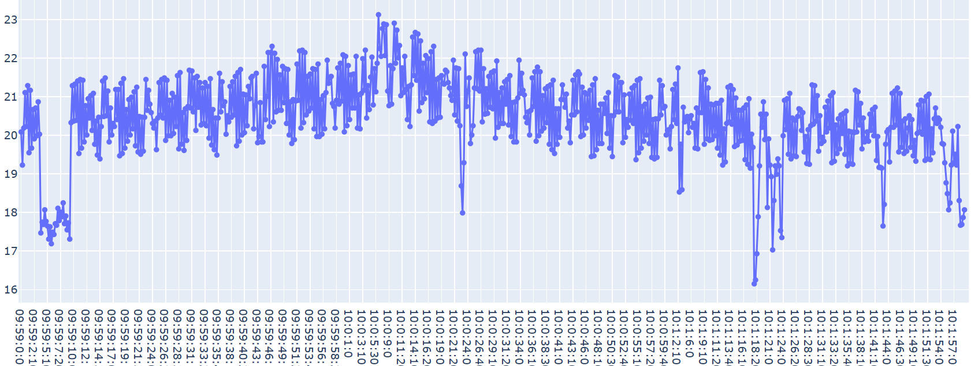

**Décimo corte | 11 corte la hora 10:02**

|  |  |  | A mano | Real |
| --- | --- | --- | --- | --- |
| Tronco | Inicio | Grosor(cm) | Tiempo(seg) | Tiempo(seg) |
| 10 | 10:02 | 32cm | 5,98 | 6,5 |
|  |  |  | 6,58 | 7 |
|  |  |  | 4,98 | 4 |
|  |  |  | 4,15 | 5 |
|  |  |  | 5,19 | 6 |
|  |  |  | 5,34 | 5 |
|  |  |  | 5,98 | 5,7 |
|  |  |  | 5,98 | 5,2 |
|  |  |  | 6,51 | 5,8 |
|  |  |  | 6,64 | 5,9 |
|  |  |  | 6,70 | 6,8 |

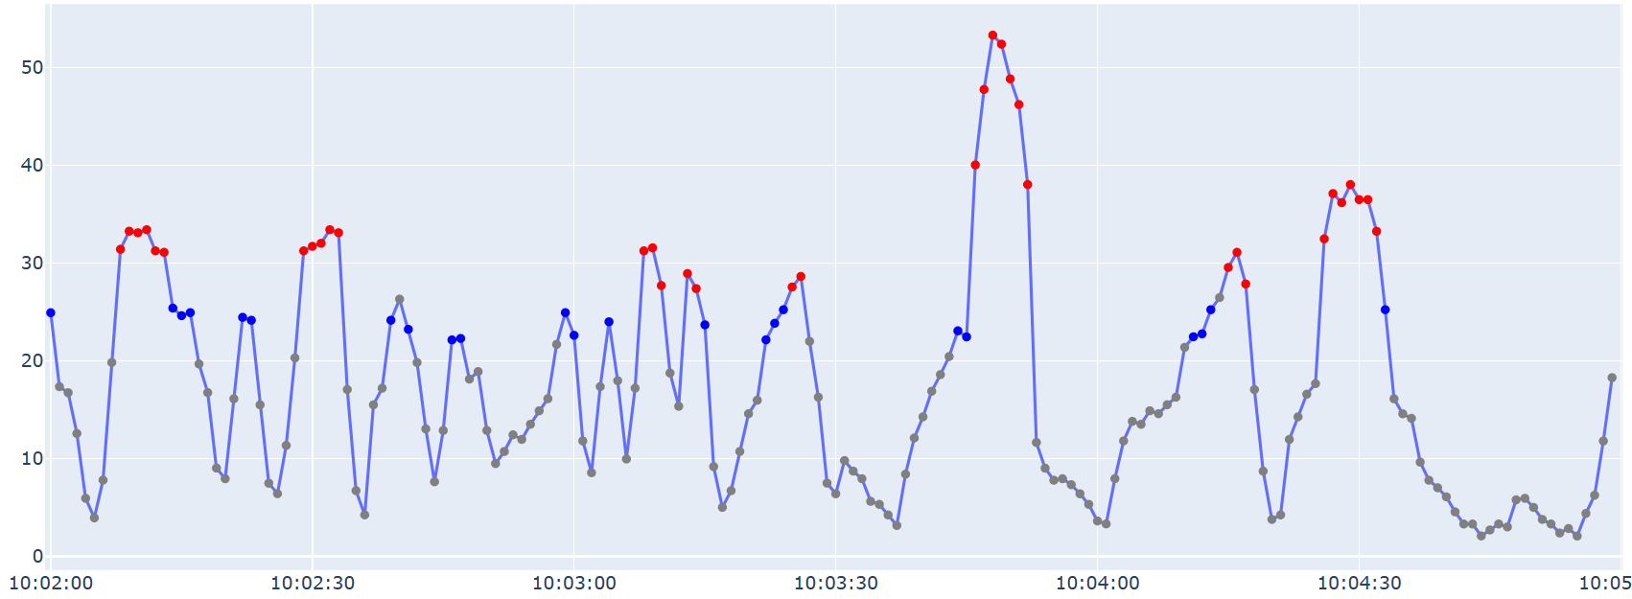

 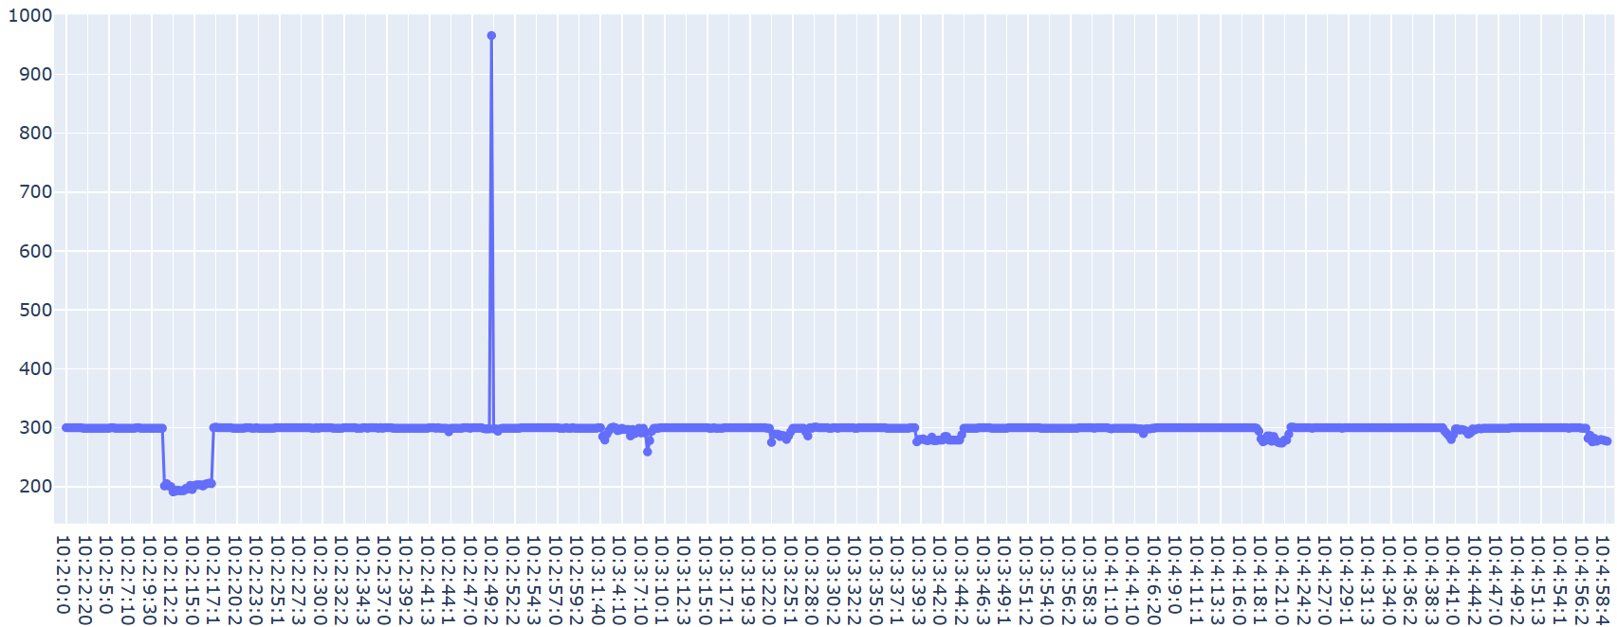

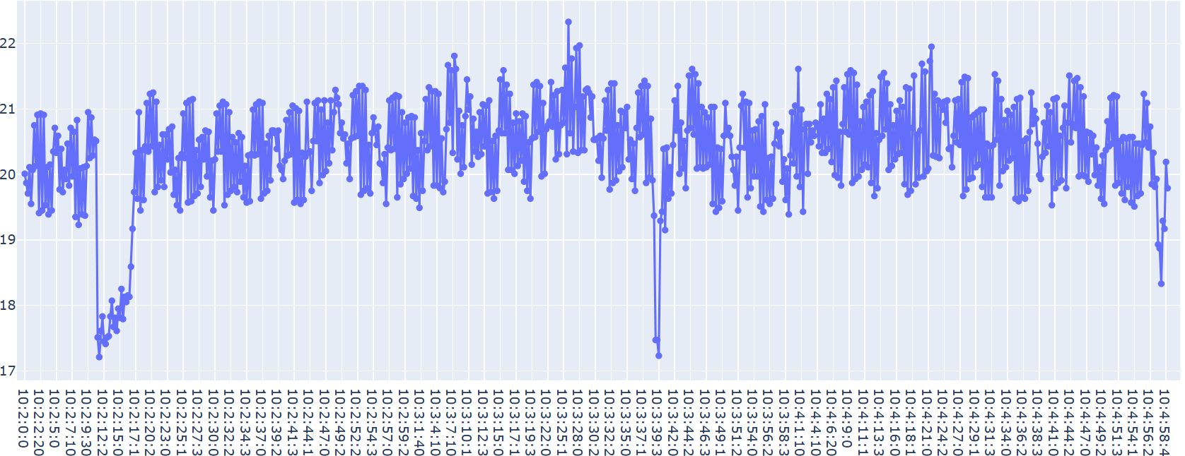

**Undécimo corte | 9 corte la hora 10:05**

|  |  |  | A mano | Real |
| --- | --- | --- | --- | --- |
| Tronco | Inicio | Grosor(cm) | Tiempo(seg) | Tiempo(seg) |
| 11 | 10:05 | 32cm | 6,25 | 7 |
|  |  |  | 6,18 | 7 |
|  |  |  | 6,19 | 7,7 |
|  |  |  | 6,57 | 6,7 |
|  |  |  | 5,52 | 6,8 |
|  |  |  | 5,78 | 7,1 |
|  |  |  | 6,25 | 5,8 |
|  |  |  | 6,25 | 6,9 |
|  |  |  | 6,57 | 5,7 |

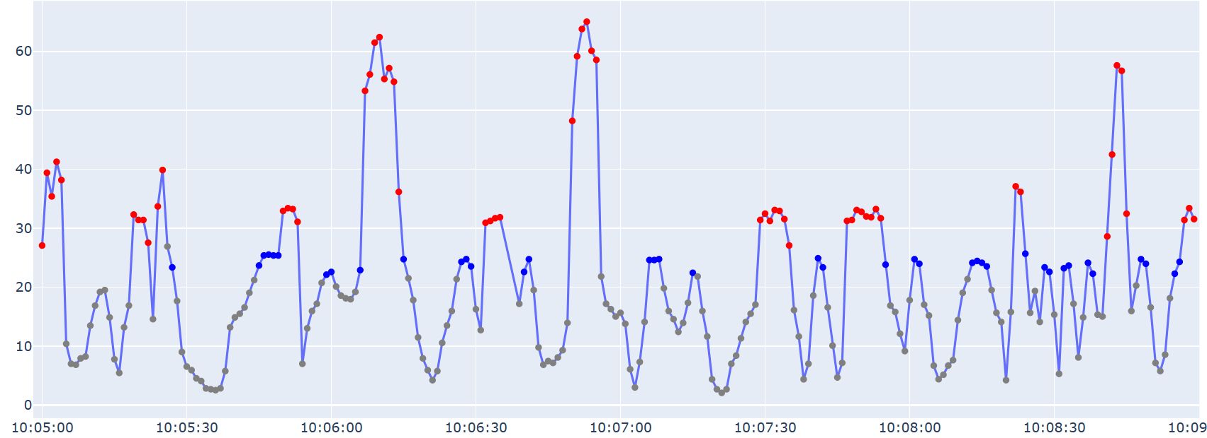

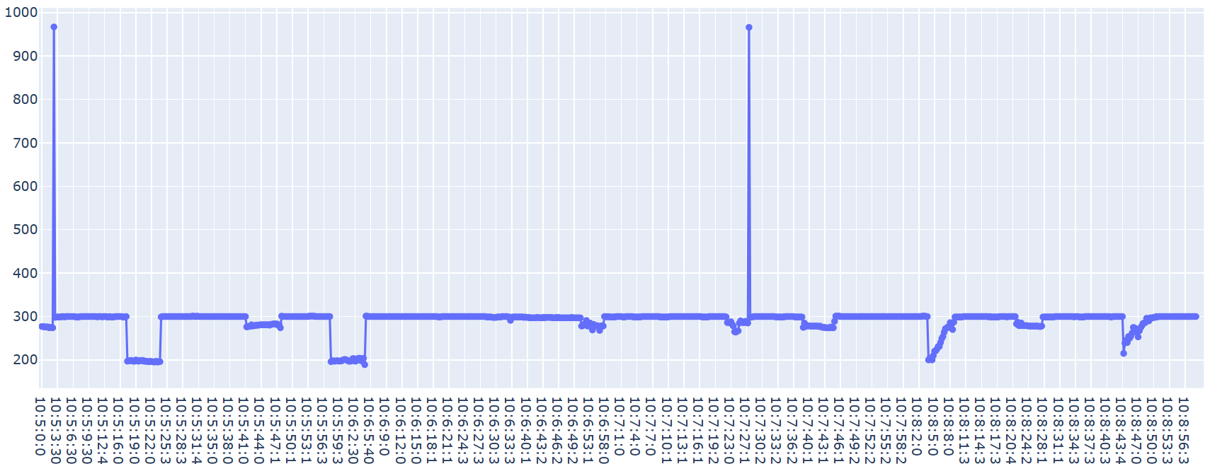

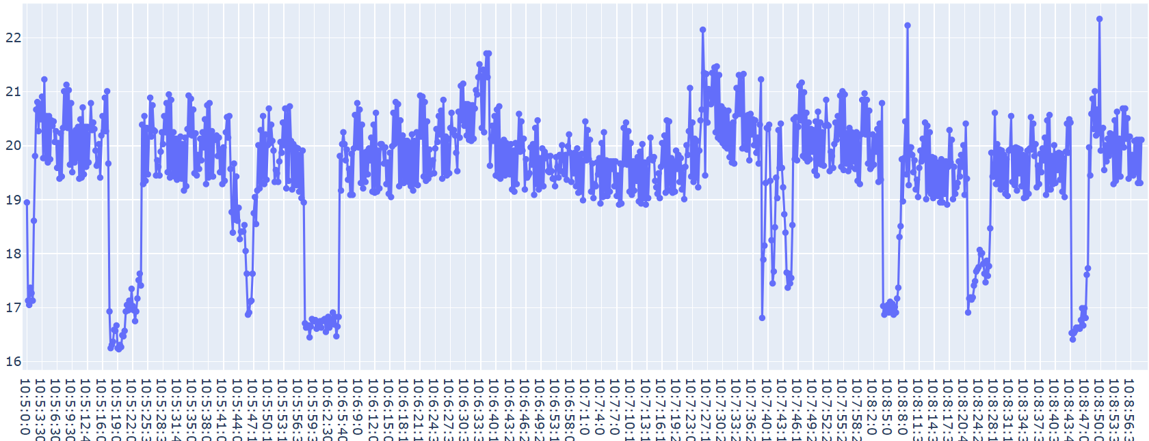

**Duodécimo corte | 12 corte la hora 10:09**

|  |  |  | A mano | Real |
| --- | --- | --- | --- | --- |
| Tronco | Inicio | Grosor(cm) | Tiempo(seg) | Tiempo(seg) |
| 12 | 10:09 | 42cm | 5,14 | 6,8 |
|  |  |  | 5,26 | 7,7 |
|  |  |  | 6,36 | 6 |
|  |  |  | 6,18 | 5.8 |
|  |  |  | 6,25 | 3.4 |
|  |  |  | 4,96 | 4 |
|  |  |  | 5,07 | 6.9 |
|  |  |  | 5,20 | 3.1 |
|  |  |  | 6,12 | 5.6 |
|  |  |  | 5,33 | 5.9 |
|  |  |  | 6,30 | 4.8 |
|  |  |  | 5,92 | 5.9 |

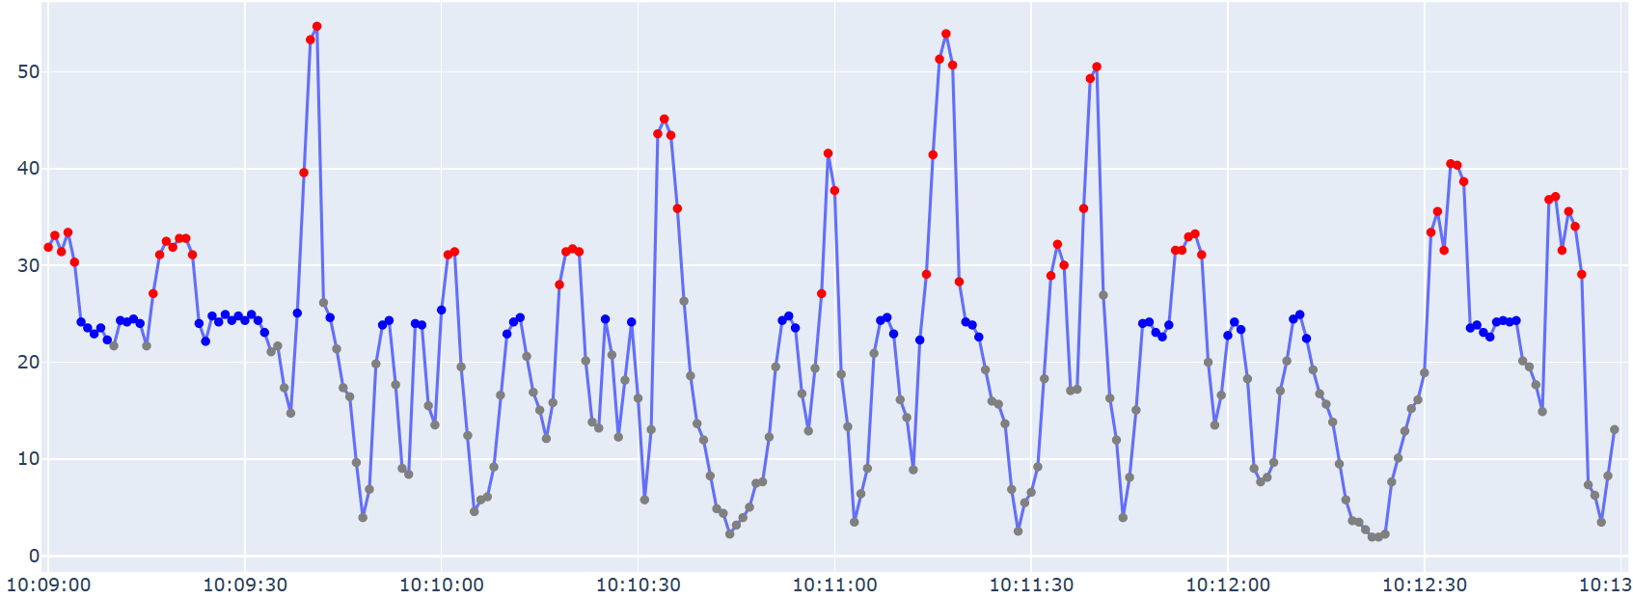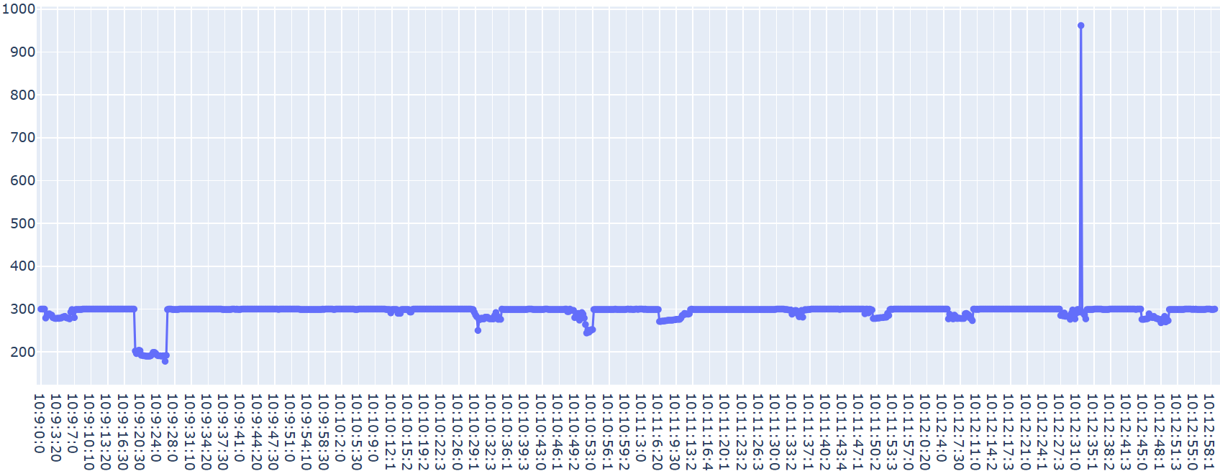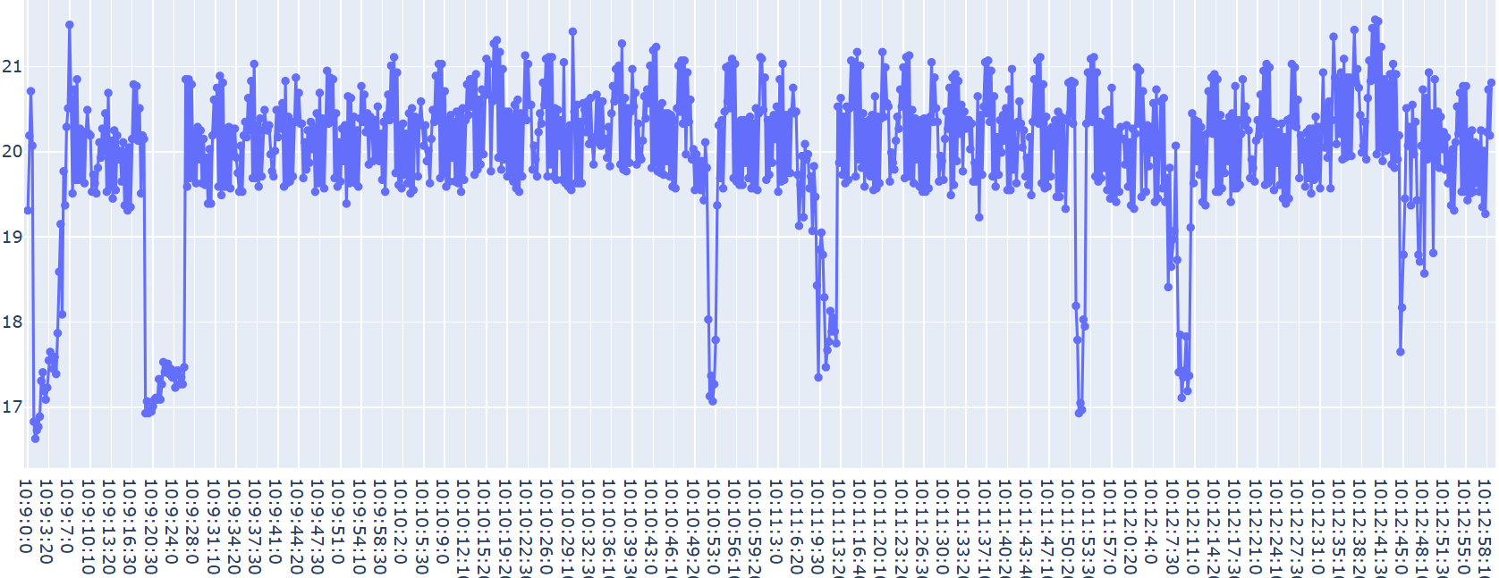

**Decimotercer corte | 9 corte la hora 10:13**

|  |  |  | A mano | Real |
| --- | --- | --- | --- | --- |
| Tronco | Inicio | Grosor(cm) | Tiempo(seg) | Tiempo(seg) |
| 13 | 10:13 | 34cm | 5,14 | 7 |
|  |  |  | 5,07 | 6.1 |
|  |  |  | 4,81 | 6.1 |
|  |  |  | 5,52 | 4 |
|  |  |  | 5,40 | 4.4 |
|  |  |  | 5,12 | 5.2 |
|  |  |  | 5,89 | 7.8 |
|  |  |  | 6,11 | 6 |
|  |  |  | 5,53 | 5.7 |

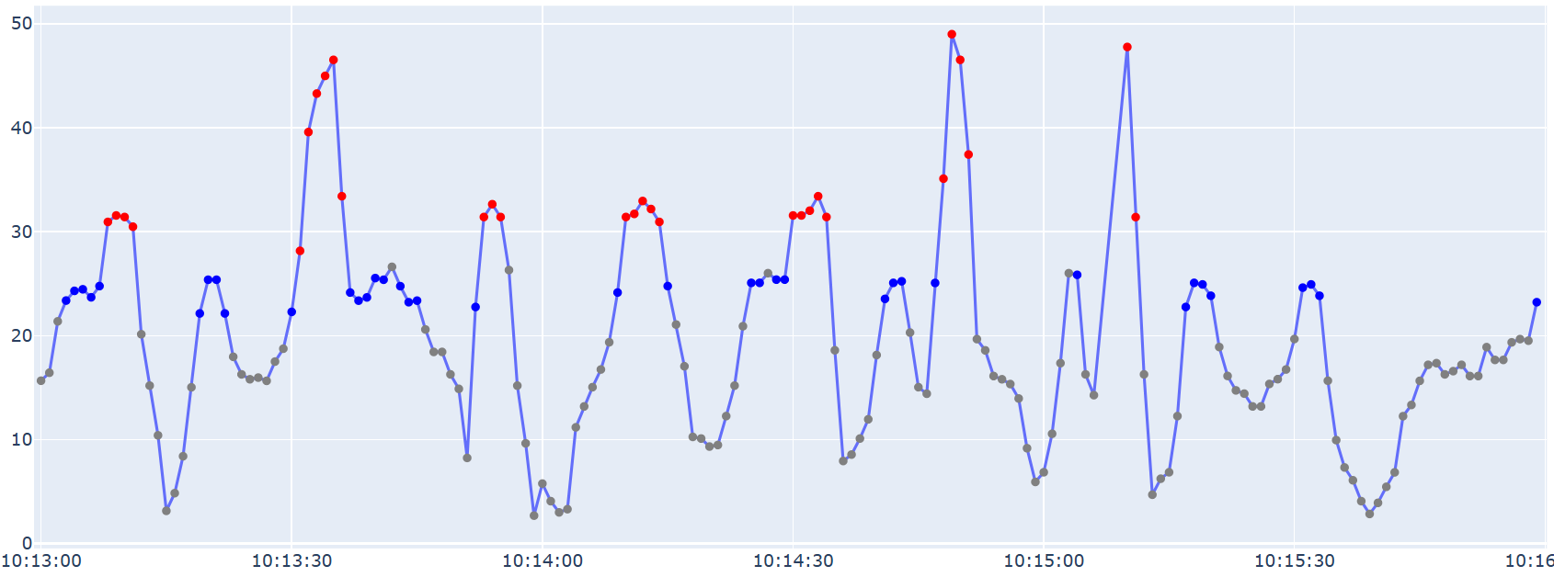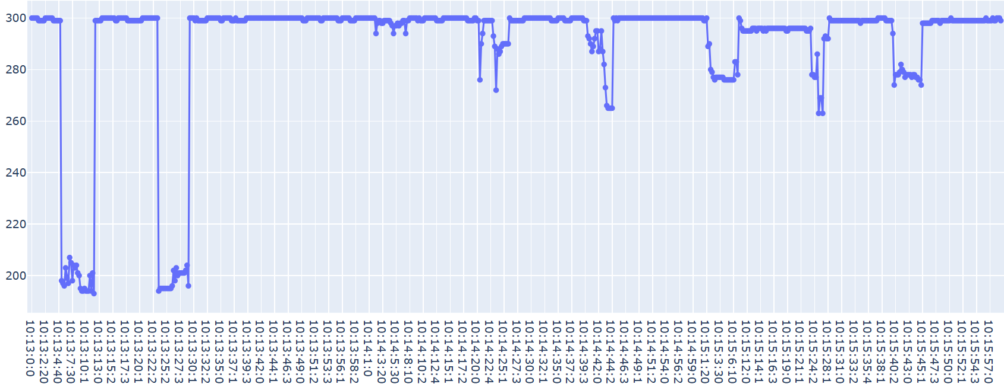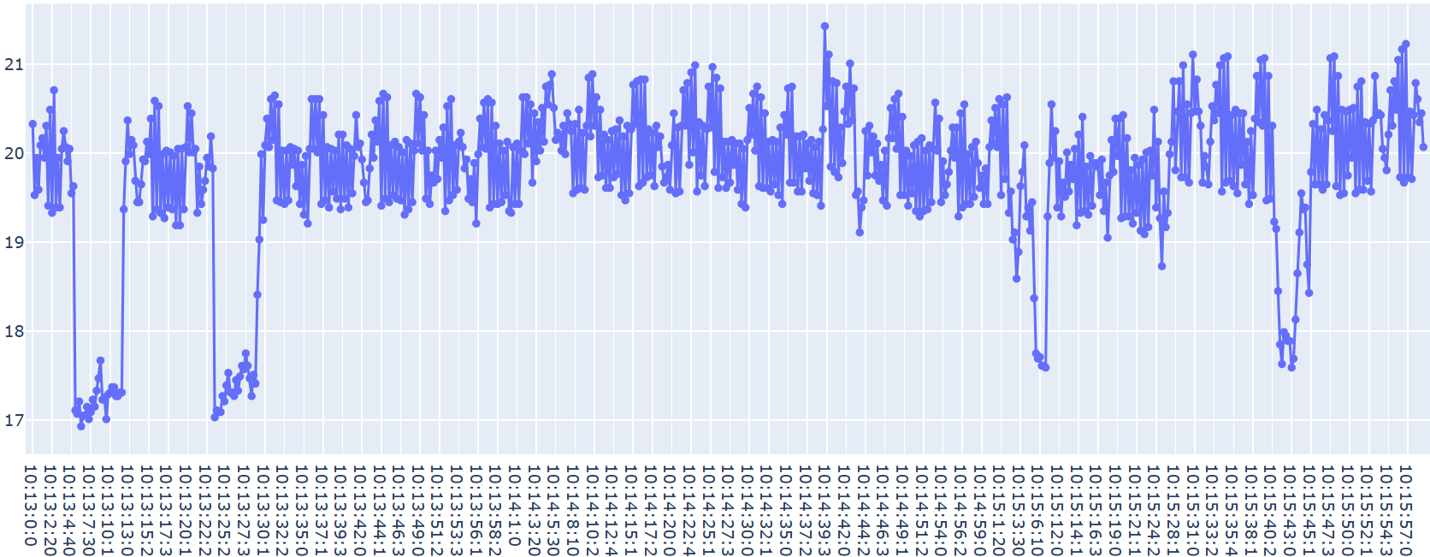

**Decimocuarto corte | 9 corte la hora 10:16**

|  |  |  | A mano | Real |
| --- | --- | --- | --- | --- |
| Tronco | Inicio | Grosor(cm) | Tiempo(seg) | Tiempo(seg) |
| 14 | 10:16 | 32 | 6,63 | 5 |
|  |  |  | 5,92 | 6.7 |
|  |  |  | 5,22 | 5.2 |
|  |  |  | 5,97 | 7 |
|  |  |  | 5,66 | 6.2 |
|  |  |  | 5,39 | 7.2 |
|  |  |  | 5,85 | 4.3 |
|  |  |  | 5,15 | 5.8 |
|  |  |  | 5,85 | 5.8 |

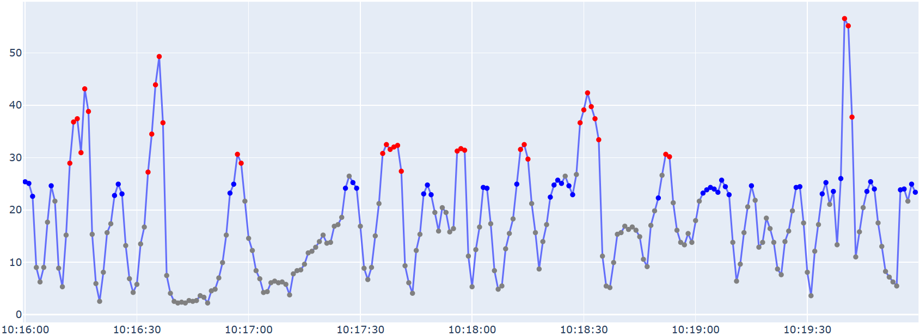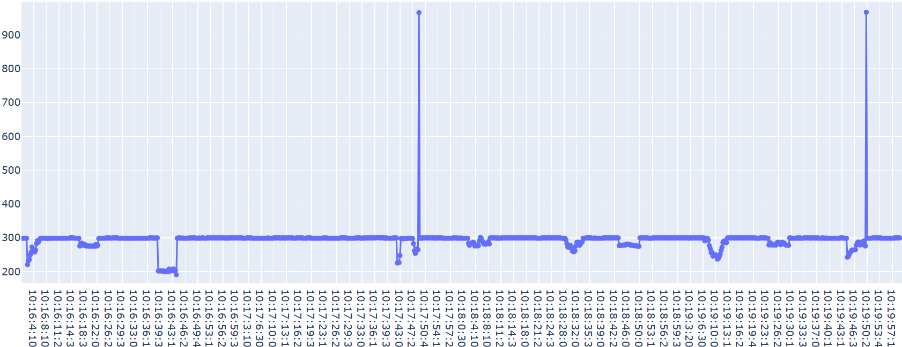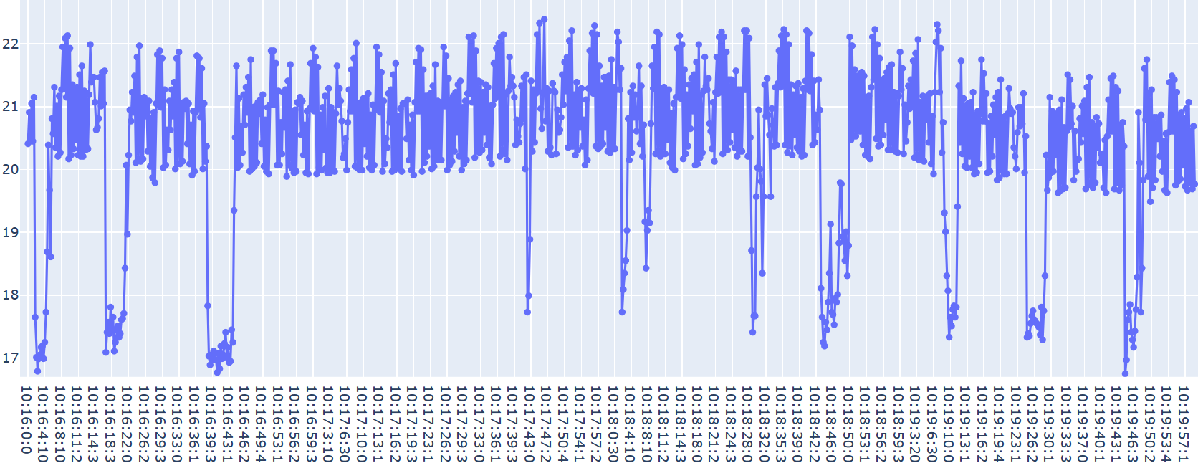

**Decimoquinto corte | 12 corte la hora 10:20**

|  |  |  | A mano | Real |
| --- | --- | --- | --- | --- |
| Tronco | Inicio | Grosor(cm) | Tiempo(seg) | Tiempo(seg) |
| 15 | 10:20 | 44 | 4,66 | 6 |
|  |  |  | 6,06 | 6.8 |
|  |  |  | 6,31 | 7 |
|  |  |  | 4,42 | 3.2 |
|  |  |  | 4,47 | 4.9 |
|  |  |  | 4,58 | 3.6 |
|  |  |  | 4,60 | 5 |
|  |  |  | 4,16 | 5.6 |
|  |  |  | 5,78 | 6 |
|  |  |  | 5,86 | 6.2 |
|  |  |  | 6,65 | 4 |
|  |  |  | 6,38 | 6 |

